Internship Final Project Report
Crop Yield Prediction using Machine Learning
Name: Nithishkumar S
Domain: Data Science & Machine Learning
Company: Uniconverge Technologies (UCT), via Edunet Foundation
GitHub Repo: https://github.com/nithishkumars21/upskillcampus.git
1. About the Company
Uniconverge Technologies (UCT) is the organization hosting this Data Science & Machine Learning internship, delivered through the Edunet Foundation's learning platform. The internship's project areas — agriculture, predictive maintenance, smart city systems, and industrial manufacturing — reflect current demand areas in applied data science.
2. Introduction
This project focuses on predicting agricultural crop yields using historical cultivation and production data. By leveraging machine learning, the goal is to understand the relationship between input costs (cultivation and production expenses) and the final yield a crop produces, giving a data-driven basis for comparing crops and states on efficiency.
3. Dataset
The internship's project brief described a single unified dataset covering Crop, Variety, State, Quantity, Production, Season, Unit, Cost, and Recommended Zone in one table. The files actually provided did not match that description — instead there were 5 separate tables at different levels of detail (a crop x state cultivation cost/yield table, a national multi-year production table, a crop variety reference table, a national price index table, and a broad macro agriculture statistics table). These do not merge into one row-per-record table, since they represent different levels of granularity. The crop x state cultivation cost and yield table (49 rows, covering multiple crops across several Indian states) was used as the modeling dataset, since it was the only one with a clean numeric target column.
4. Data Cleaning
Column names across all datasets were stripped of extra whitespace and stray quote characters for consistency. Missing values in the national production dataset were filled with zero for crops where no data was recorded for a given year. The cultivation dataset itself had no missing values in its core columns.
5. Exploratory Data Analysis
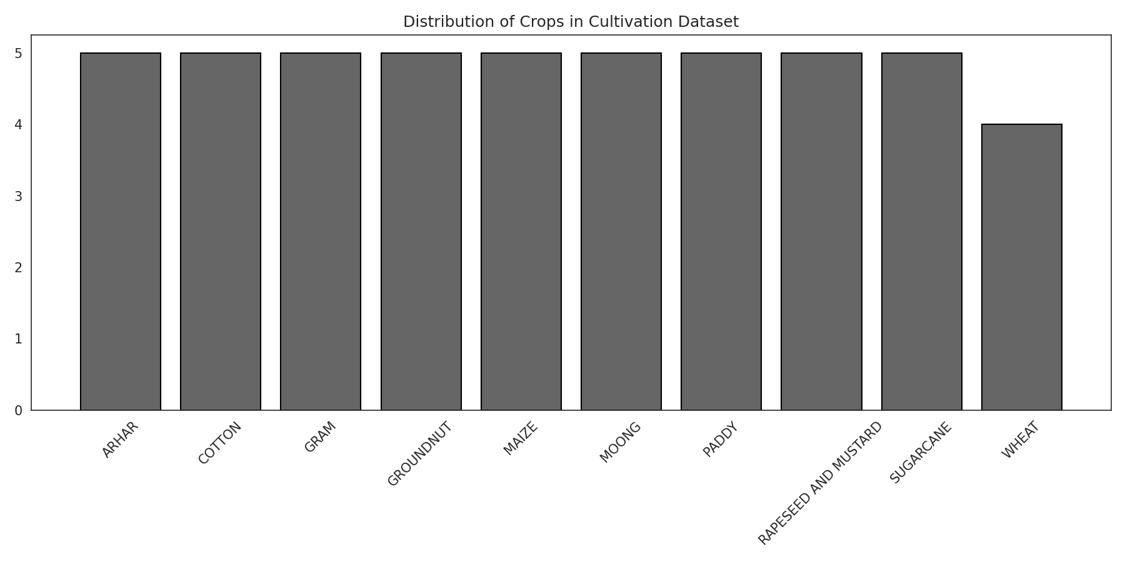
Figure 1: Distribution of crop-state records in the cultivation dataset.
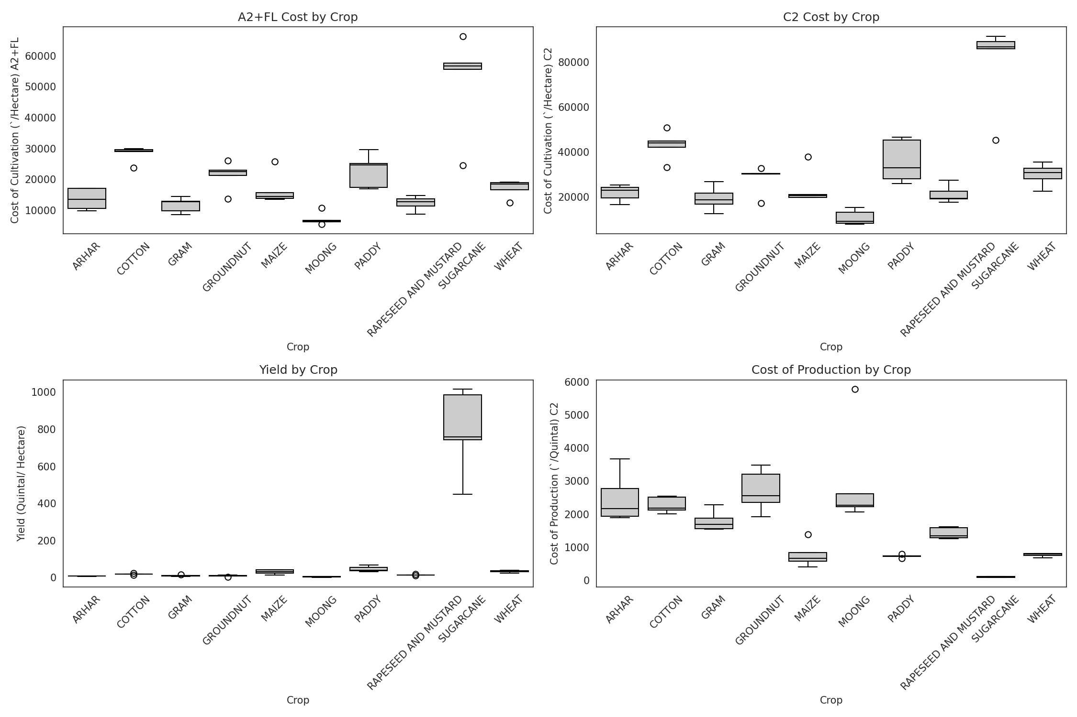
Figure 2: Cultivation cost (A2+FL, C2), yield, and production cost, broken out by crop.
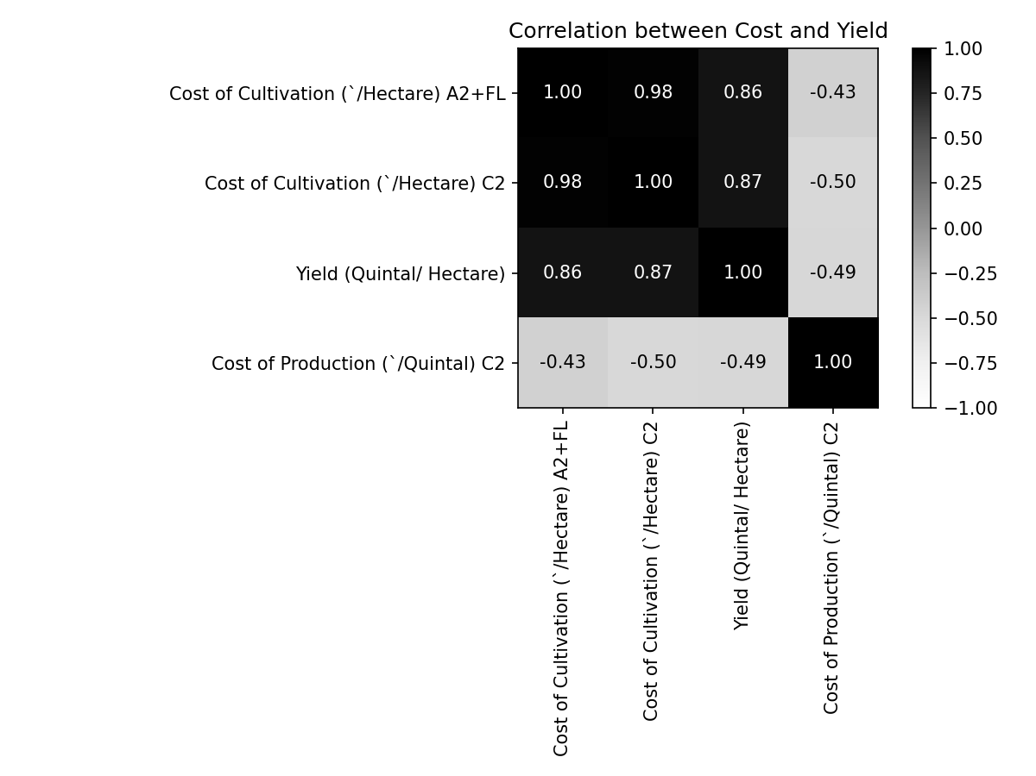
Figure 3: Correlation between cultivation cost, production cost, and yield.
The correlation analysis shows a strong positive relationship between cultivation costs (A2+FL and C2) and yield, indicating that higher-investment cultivation tends to produce higher yields across the crops in this dataset.
6. Machine Learning Model
A Random Forest Regressor was implemented using Crop, State, and both cultivation cost columns (A2+FL and C2) as features, with Yield (Quintal/Hectare) as the target. Categorical fields (Crop, State) were label-encoded. The dataset was split into training (80%) and testing (20%) sets, and the model was trained with 100 estimators.
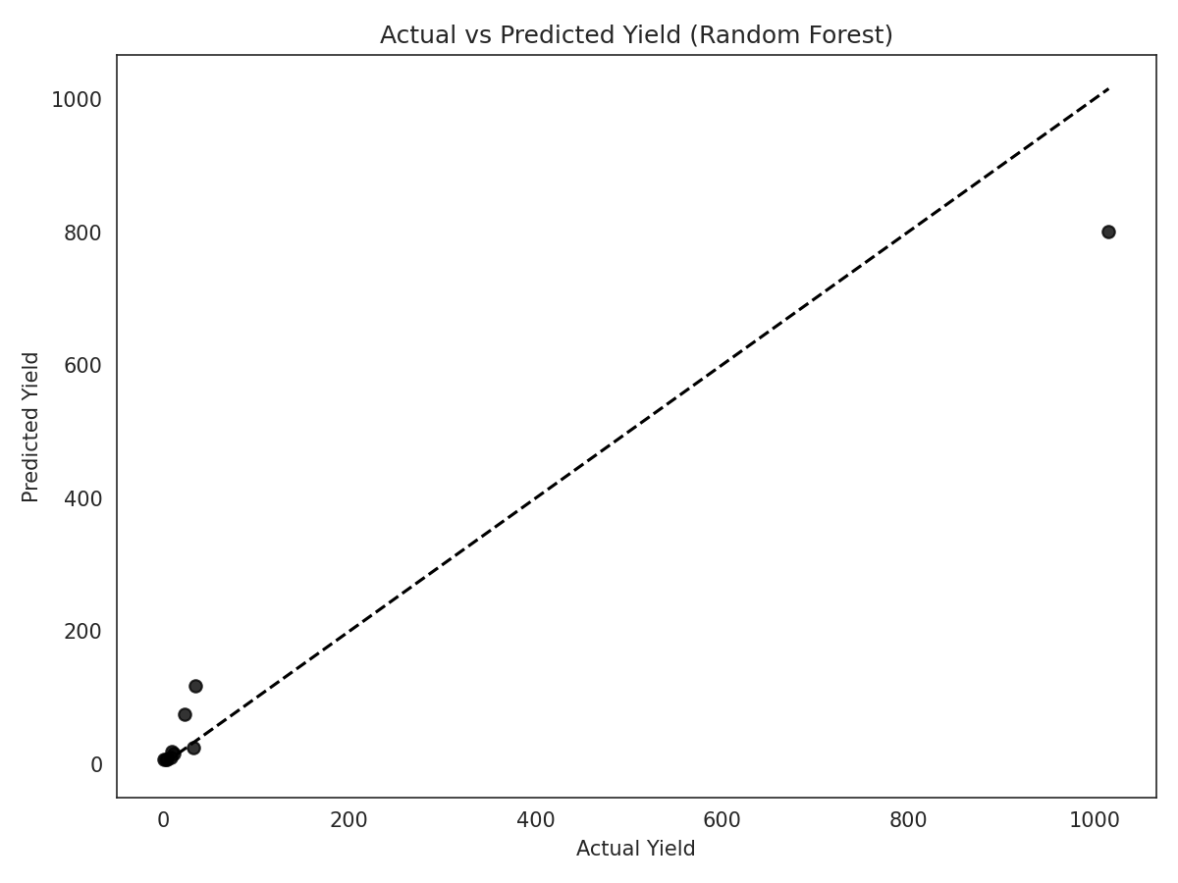
Figure 4: Actual vs. predicted yield on the test set.
7. Results
Model Performance:
- Mean Squared Error: 5601.27
- R² Score: 0.94
The model explains the large majority of variance in yield on the test set, indicating a strong fit between the cultivation cost features and actual yield outcomes.
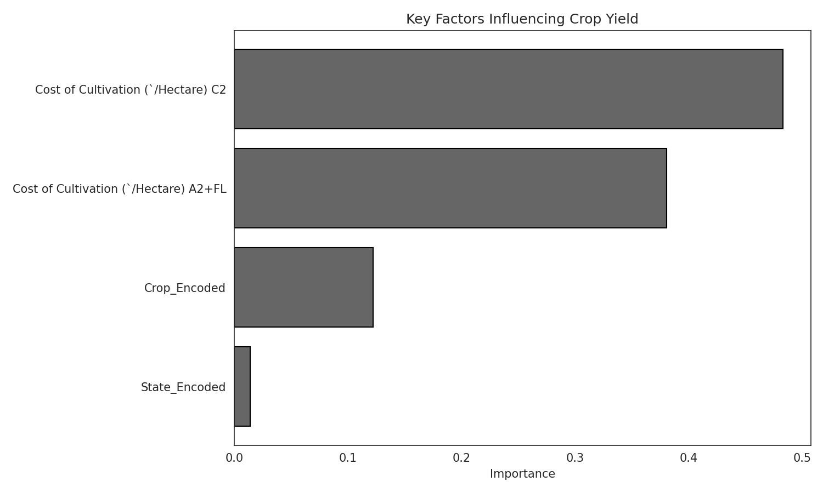
Figure 5: Feature importance from the Random Forest model.
Feature importance analysis shows that C2 cultivation cost (48.3%) and A2+FL cultivation cost (38.1%) are the dominant predictors of yield, together accounting for over 86% of the model's decision-making. Crop type contributes a further 12.2%, while State contributes minimally (1.4%) — indicating that cultivation investment level matters far more to yield outcomes than geographic location alone.
8. Conclusion
Cultivation costs and crop type were the strongest predictors of yield in this dataset. Machine learning can effectively assist in predicting agricultural output based on investment inputs, offering a quantitative starting point for planning cultivation spend across different crops and states. This kind of model could support farmers and policymakers in comparing expected returns before committing land and capital to a particular crop.

9. Learnings
I learned data science and machine learning process and basic level of the codes. Data cleaning process and data collecting methods. The intern ship will provided more videos and handbook notes I can’t study full book to downloadable but I learned something from the book pdf. And the videos will be a more practical and understanding way hands-on experience so it will help more growth for the understanding the Data Science & Machine Learning. I have to new experience from the internship for a data science and machine learning course and details. Now my knowledge level is do in this project shows the learning from the internship.
the 6weeks internship will be more helpful for me improve the data science and machine learning skill development. Thank you for your opportunity give to me.

